APRA CPS 230 Compliance for Log360
Automate APRA CPS 230 compliance and fortify cybersecurity resilience for financial institutions.
Region: Australia | Type: Financial Services, Incident Management, Operational Resilience | Category: Compliance | Pricing: Free

Overview
The APRA CPS 230 compliance extension in Log360 helps organizations meet APRA Prudential Standard CPS 230 Operational Risk Management, effective July 2025, which requires APRA-regulated entities to manage operational risks and maintain critical operations through disruptions by providing centralized log management, operational resilience monitoring, and third-party risk visibility. The platform supports APRA CPS 230 requirements for operational risk controls, business continuity monitoring, service provider management, technology risk, incident response, governance accountability, and change management.
For Operational Risk Identification and Internal Controls, Log360 monitors Windows system events, event logs, policy changes, network device configuration, and GPO auditing to provide continuous visibility into control effectiveness and risk indicators. To address Business Continuity and Resilience Monitoring, the platform monitors backup and disaster recovery jobs, policies, infrastructure, IAM, and malware detection events to verify backup and recovery controls are functioning for critical operations. The extension also supports Service Provider Risk Management by providing capabilities that monitors cloud storage integration, team and member management, AWS IAM activity, Entra ID application management, and third-party access events to audit all service provider interactions.

Key Features
- Technology Risk and System Integrity: Log360 monitors Windows software updates, registry changes, program inventory, application whitelisting, and antivirus threat detection to ensure system integrity and timely patching of operational systems.
- Incident Detection and Operational Response: Log360 integrates FireEye, Trend Micro, McAfee, Windows Threat Detection, network attack, and cloud security incident reports to identify threats that could disrupt APRA-regulated operations.
- Governance and Accountability: Log360 monitors Active Directory user and group auditing, Entra ID role and directory management, user account changes.
- Change Management and Configuration Control: Log360 monitors policy changes, Windows registry modifications, network device rule and configuration management to detect unauthorized changes that could impact critical operations.


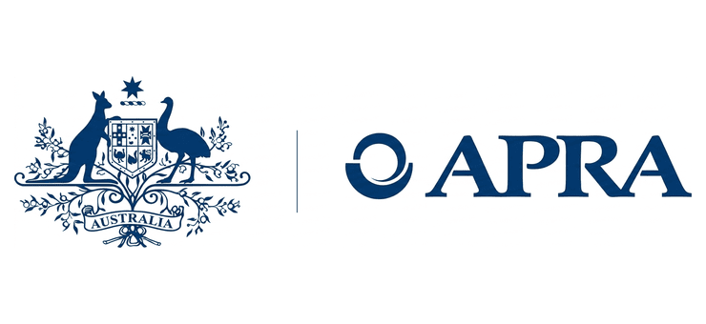

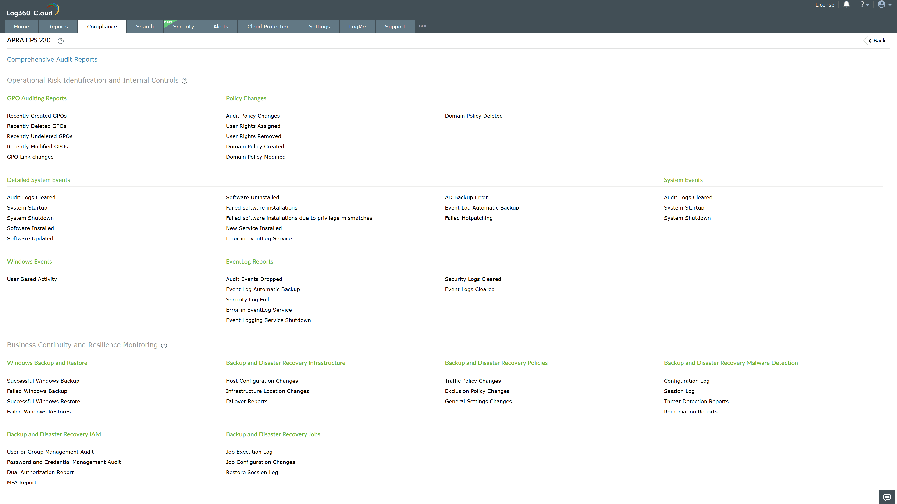
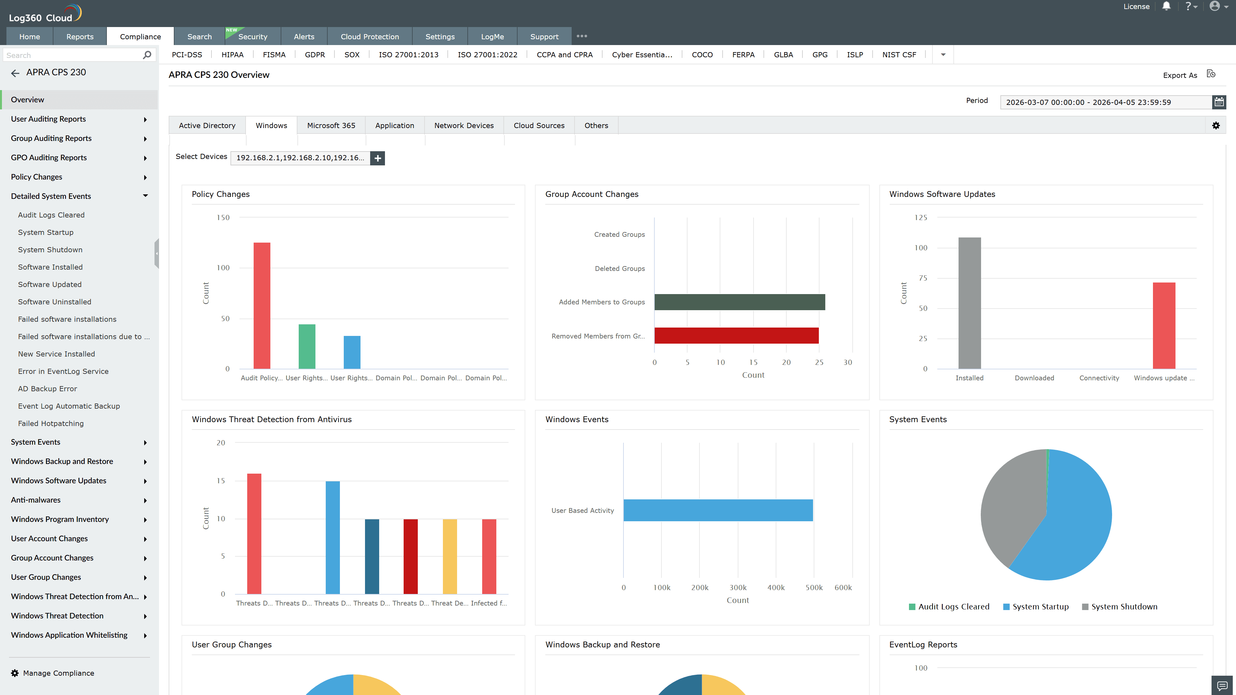
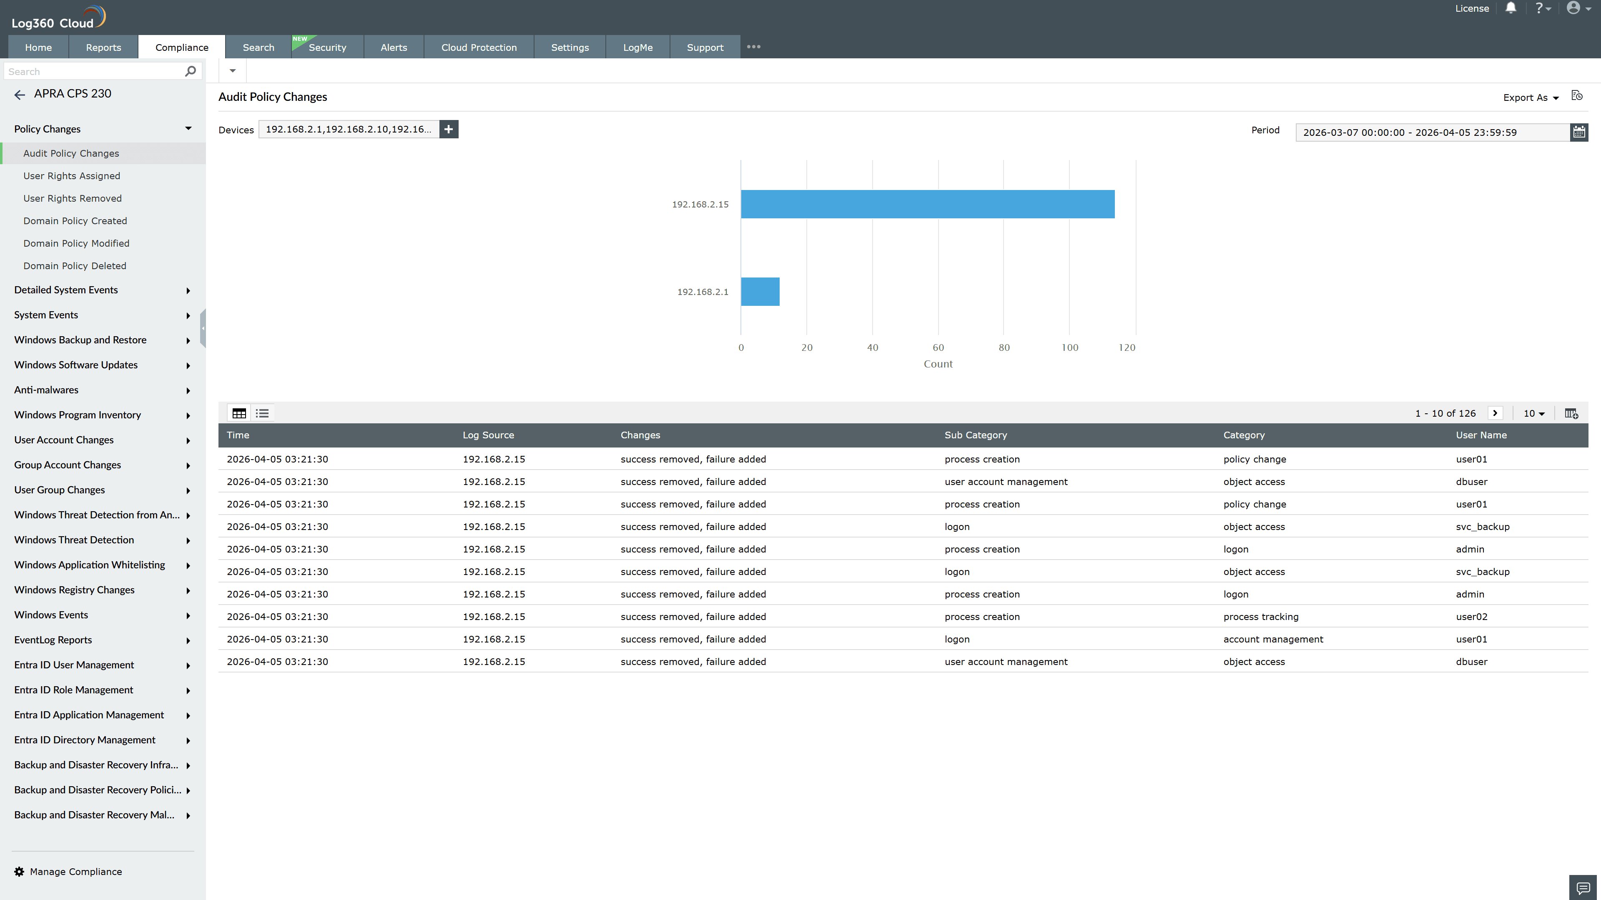
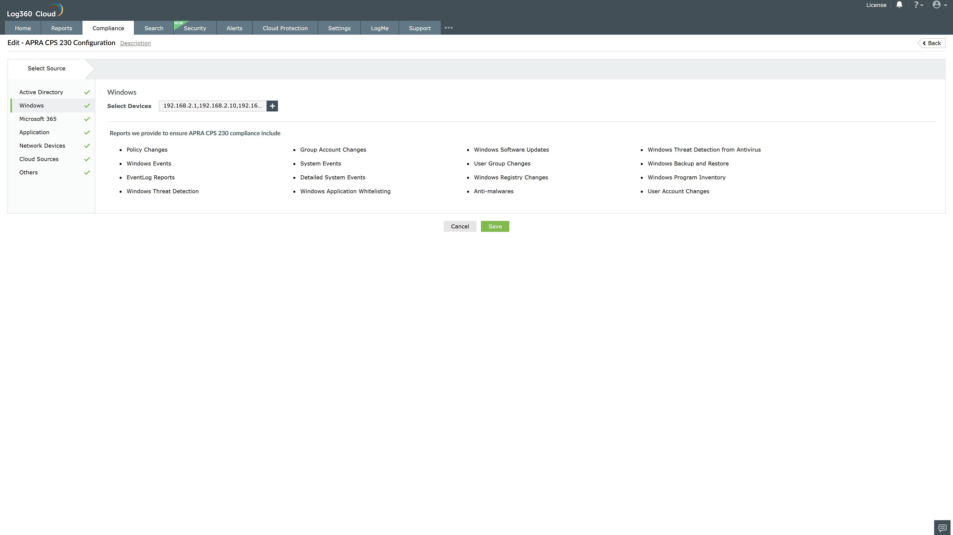
Valid Submission : Yes
Supported Editions : Free, Basic, Standard, Professional, MSSP
Help Document : https://www.manageengine.com/log-management/help/integrations/compliance-extensions.html
Help Video : Not provided
Tags : Log360, Compliance, Privacy monitoring, Data privacy, Regulatory compliance
Supported DCs : US, IN, JP, CA, AU, UK and EU
Privacy Policy:
Terms of Service:
Release Notes:
Predefined reports for the APRA CPS 230.

